Keil MicroVision Installation Guide - V4

2/6/2016 by Sukgi Choi

Reference: MDK5 Getting Started.pdf by STM

Chapter I. Download Keil MicroVision

Keil named its IDE, MicroVision (uV or uVision in short). The current version is uVision5. Then Keil adds several software Packs to it and calls it MDK (Microcontroller Development Kit). uVision is a subset of MDK.

1. Visit <www.keil.com> site. Down scroll and click on "uVision IDE and Debugger".

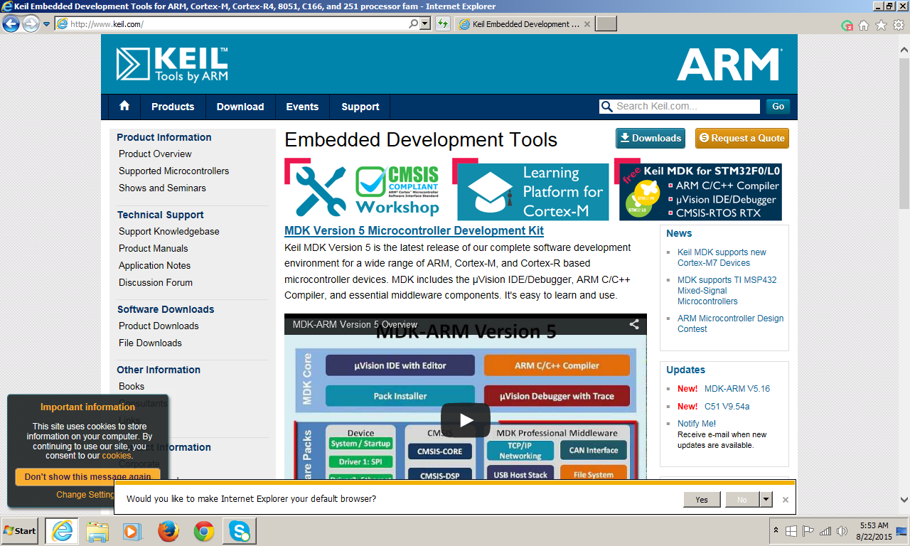

2. Click on Download on the menu bar.

3. In the bottom box of the screen, click, MDK-ARM.

4. Register your name and Submit.

5. Download and save <MDK516A.exe> in your computer. This is an installation program, not uVision itself. The file is huge close to 400MB.

6. Click on MDK516A.exe to install uVision It runs the installation program.

7. When all done, the desktop shows the Keil uVision icon.

8. Pack Installer window pops up. This is an important step. Do not skip.

9. For installation, select the device, Cortex M4 on the left pane. Then the pack list is updated. It takes more than 10 minutes. Be patient. This means that the pack files are huge. Watch the bottom of the Output window to check the action status.

10. Given enough time, Pack installation window pops up for the second time. This time, the device information is required. Select STM32F303VCT6. Select STM32F303VC Then install necessary packs. Select all packs for installation..

11. Pack installation takes around 30 minutes. Some packs request license agreements.

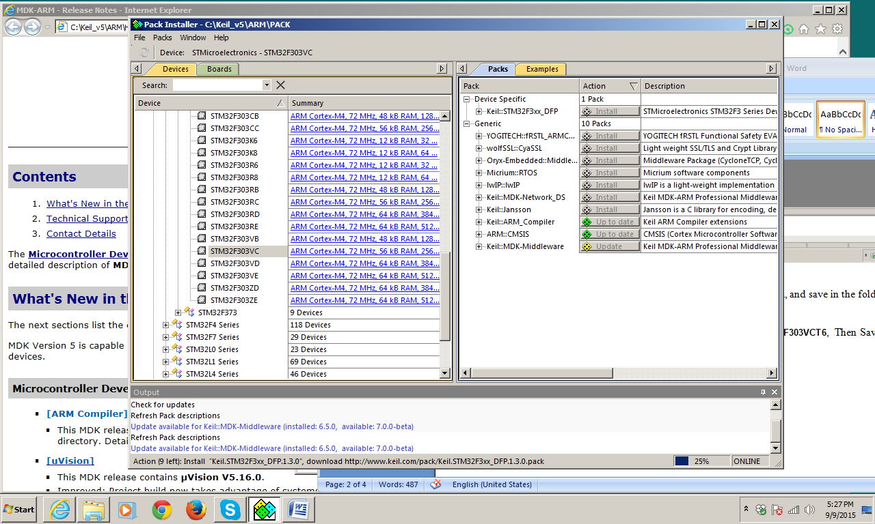

12. Installation is complete.

Chapter II. Loading STM32F3Base project.

1. Create a folder in your computer with a proper name such as EECE237_code.
2. Download STM32F3Base folder from the BBLearner.
3. Run Keil uVision

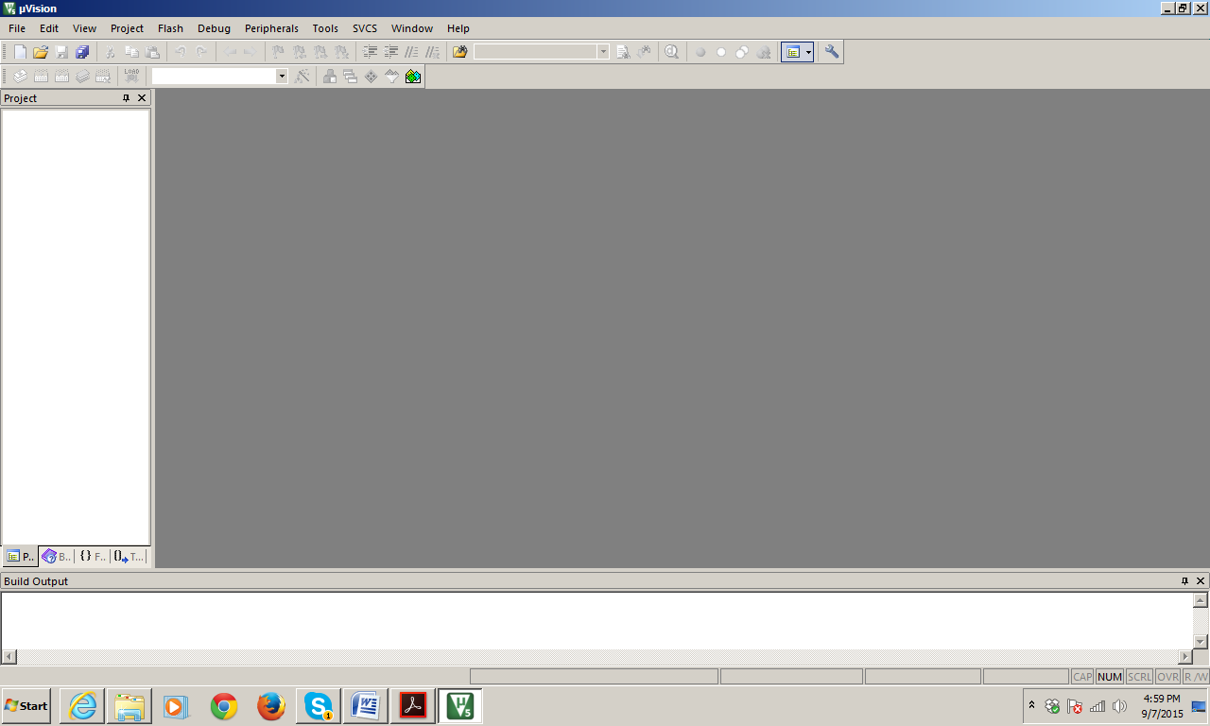

1. Click, Project>Open Project...
2. Select STM32F3Base>MDK-ARM>STM32F3_Base.uvprojx.
3. Once the project is loaded, click on user>Assembly_template.s on the left pane. The main window shows the assembly code template.
4. Click, Project> Options for Target Target1.... If a different screen pops up than what is shown below, close the screen and try again. Select Target Tab.

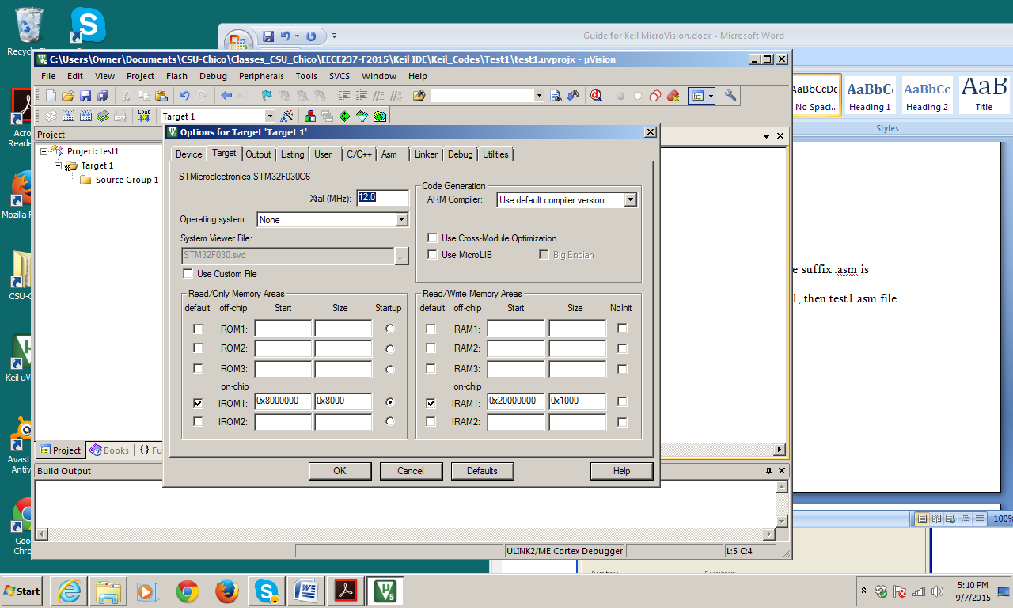

* 1. In Read/Only Memory Areas

Enter IROM1 start 0x8000000 (6 0's)

IROM1 size 0x40000

* 1. Check Use MicroLIB
  2. In Read/Write memory Areas

Enter IRAM1: Start 0x20000000 (7 0's)

IROM1: size 0x8000

1. This time, click on Debug tab. Select ST-Link Debugger in the pull-down menu next to the right-side settings. Select use radio-dial. Then OK.

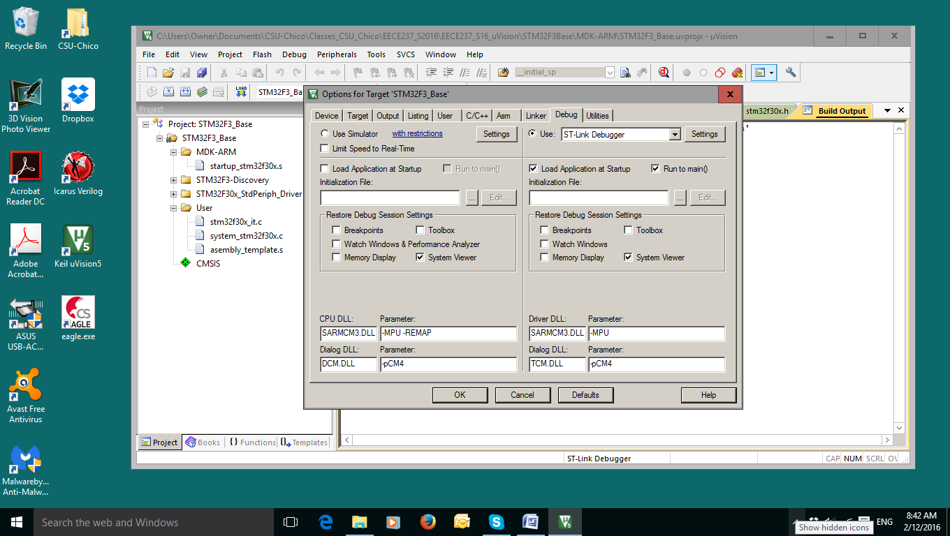

1. Click on Device Tab. The device should be STM32F303VC. If not, the installation was not complete.
2. The next step is to run Assembly and to create an executable file, which is also called a target file. The process of assembling (or compiling) and creating a target is called building a target. Click, Project > Build Target. The "Build Output" box at the bottom shows the outcome of the assembly including any error messages if there are.
3. If the error box displays, "0 error.", the assembling is done successfully. Non-zero error means something is wrong.

Chapter III Connecting uVsion to STM Discovery Kit

A computer is connected to the discovery kit via a USB cable. Actually this USB cable goes to ST-Link on the discovery kit, not directly to STM microcontroller. ST-Link is a embedded debugger which handles the traffic between the controller and the computer. As for uVision, it talks to ST-Link, not to the controller. On the discovery PCB, the small chip close to USB ports is ST-Link.

The first task is to install a USB driver for ST-Link on your computer. The Blackboard Learner has STSW-link006 folder, which is a wizard for the driver.

1) Download STSW-link006 folder and save in your computer.

2) Do not connect the Discovery kit to the computer.

3) Run <stlinkwinusb_install.bat> file inside the STSW-link006 folder. This will install the USB driver for ST-Link by itself.

To make sure that you have install the USB driver correctly, BlackBoard Learner has a demonstration program, called Blinky. Download this folder and save it in your computer. Now the task is to download this Blinky program from uVision to the Discovery Kit.

1. Connect the Discovery kit to the computer USB port.
2. Run uVision.
3. Open the Blinky project. Blinky>Boards>ST>STM32F3-Discovery>Blinky>Blinky.uvprojx.
4. Build Target. It should run with 0 error and 0 warning.
5. Now make a connection to ST-Link. Project>Options for Target>Debug.
6. Select "Use ST-Link Debugger" in the right side of the window. This turns off simulator. Check the setting for verification.
7. Close the window.
8. In main window, Debug>Start/stop Debug session. After a while, the window changes. Then click Debug>Run.
9. Now the Discovery kit starts to blink. The program is downloaded to the flash memory inside the controller. You may close uVsion now. Blinky continues running without uVision.

This is one way of downloading a file to the Discovery kit while debugging is under progress. Once debugging is all done, then the program is downloaded directly by Flash. This will be discussed later.

Now you are sure that USB driver is installed properly.

